Christina Martin Hosted the 2007 “30 Under 30 Awards”
Benefiting City Of Hope and Honoring 30 Individuals Under the Age of 30 for
Their Successes and Contributions to the Arts and to Society.

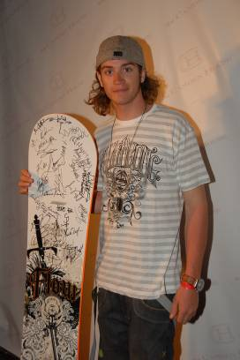
May 4, 2007 (Beverly Hills, CA)-The 2007 “30 Under 30 Awards” recognized 30 outstanding young leaders from film, fashion, music, politics and sports for their accomplishments and the positive impact of their work. Described as 30 of the sharpest, sexiest, most successful individuals under the age of 30, this year’s honorees included tennis-pro Lera Solovieva, recording star Andrew McMahon, actor Ben Crowley, professional snowboarder Scotty Lago, actress Sarah Foret, creative designer Asher Ross, model Jojo Holland and Grammy winning artist Chamillionaire. Though they come from different areas, the honorees have in common a demand for excellence in themselves which serves as an example and inspiration to us all. It is this pursuit to achieve great things that likewise fuels the mission of City Of Hope, leading translational research that converts science discoveries into new treatments for patients.

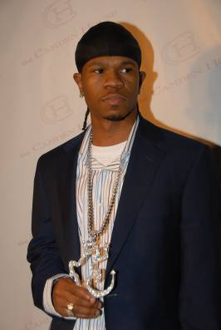
Organized by Christina Martin of Equity Strategic Relations, the annual awards took place yesterday evening in Beverly Hills to a reception of celebrities, press and industry guests. The official partners to the event were Tommy Bahama Rum, Spa Angels, Joico, Xtreme Lashes, Culture & Propaganda Clothing, Prissy Girl Boutique, Fairytale Brownies, Izze, Varnish Nails, Goka Designs, Vera Bradley, Poleci Clothing, Flow Snowboarding, Indie Appeal, Script magazine, Fileena Jewelry, Annatarian Eco-Couture and The Camden House of Beverly Hills.

The Host Committee this year included luminaries from Smithfield Street Productions, Final Draft, Fox Searchlight Pictures, JT Entertainment, Bold Films, Music Plus TV, Genlux Magazine, Epic Group Worldwide, Iluminus, Alternative Exposure, and Showtime. Special music entertainment was provided by DJ Carlos Ramirez. Tanya Nea Thayer directed the audio/visual presentation. Bai Ling, Keesha Sharp, Hoobastank, Mauro L. Metini and Scott Elrod were in attendance. Ryan Star and the band Waking Matthew performed at the intimate pre-awards party.
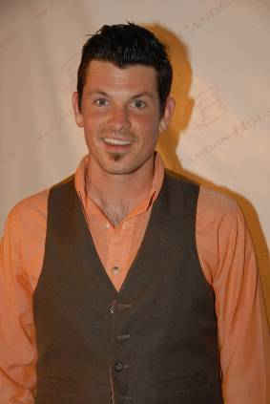
Also among the 30 honorees this year were Paulie Litt, Danica Patrick, Joshua LeBar, Ace Young, Julian Medina, Christina Ricci, Christian Johnston, Mayor Michael Sessions and the band Hurt. “Each day is a gift and the 30 honorees recognized last night exemplify what can be achieved when the potential of the time we are given is fully realized.”

Please direct all inquires concerning the 30 Under 30 Awards to Equity Strategic Relations, 310.272.6300 or 30under30@cmartingroup.com

